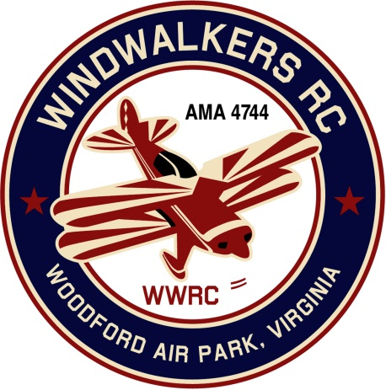
November 12, 2016
Monthly Club Meeting Minutes
Club President, Gary Stone, called the meeting to order at 10:11 a.m., November 12, 2016. The meeting was held at the Salem Church Branch Library, 2607 Salem Church Road, Fredericksburg, VA 22407. The meeting was opened with the pledge of allegiance. There were 9 members in attendance.

Secretary’s Report:

The minutes of the October 8, 2016 meeting were read. Treasurer Hank Maulsolf corrected the amount in the checking account at the beginning of October was $768.57. The minutes were approved with the corrected amount.

Treasurer’s Report:

Club treasurer, Hank Mausolf, reported that the Club a beginning balance of $768.57. After expense of $16.99 for the website and income of $50.00 from membership renewal, the ending balance was $801.58. Hank reminded the members that membership renewal is coming up. In addition to checks and cash, dues and donations can be paid through Pay Pal and credit card.

Field Safety Report:

There was no safety report.

Old Business:

The Home of the Wind Walkers sign has had plastic installed on both sides and has been reinstalled at the entrance to Woodford Air Park.

Hank Mausolf and Gary Stone reported that the October Harvest Event at Shannon Airport went off very well. We had a great static presentation. There were over 5000 attendees. The event will be held again next year. The museum now has 10 antique airplanes and has a nice display. Hank commented that it is well worth the trip. Gary said he took a stack of membership forms to the event and they were all taken by the time the event was over. Brian Mausolf got some fantastic aerial video. Check out the Shannon Airport facebook page to take a look.

New Business

We had a visitor at the meeting. He became interested in the club from the information displayed at the library and decided to come to the meeting.

Secretary Nina Grube announced that she would not be filling the position of secretary after the end of 2016.

Plans for the Christmas party were finalized. This year the party will be held on December 17, 2016 at the Four Seasons Family Restaurant, 5201 Jefferson Davis Hwy, Fredericksburg, VA 22408 . The fun will start at 1:30 p.m.

There being no further business, the meeting was concluded at 10:52.

Respectfully Submitted,

Nina C. Grube

