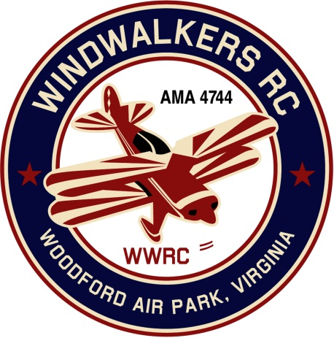
October 8, 2016
Monthly Club Meeting Minutes
Club President, Gary Stone, called the meeting to order at 12:11 a.m., October 8, 2016.
The meeting was held at the Salem Church Branch Library, 2607 Salem Church Road, Fredericksburg, VA 22407. The meeting was opened with the pledge of allegiance. .
There were 10 members in attendance.

Secretary’s Report:

There was not a meeting held during September, therefore there were no minutes recorded.

Treasurer’s Report:

Club treasurer, Hank Mausolf, reported that the Club has $758.57 in checking.

Field Safety Report:

Since during the previous time period there had been no flying because of nature’s elements, there was no Safety Report.

Old Business:

Because of the lack of response from scout troops, it was decided to put off Scout Day until further arrangements are made.

The “Home of the WindWalkers RC” sign was finished and returned to Leo.

New Business

Information concerning October Harvest event at Shannon Airport was discussed.

The Treasurer reminded members that membership renewal was coming up shortly.

There being no further matters to be brought forward, the meeting was conclude at 12:57.

Respectfully Submitted,

Nina C. Grube/wps

