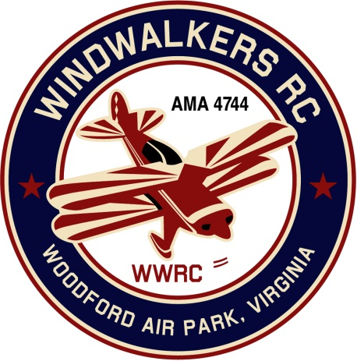
August 12, 2017
Monthly Club Meeting Minutes,
Club President, Gary Stone, called the meeting to order at 10:14 a.m. July 8, 2017. The meeting was held at Windwalkers flying field. The meeting was opened with the pledge of allegiance. There were 8 members in attendance.

Secretary’s Report:

- The meeting minutes from July 8th were read.

Treasurer’s Report:

- Correction to the July minutes published pertaining to the entry monies collected on Aviation Day.
  - (18) entries $360.00 corrected amount is $320.00 cash - $40.00 check Totaling $360.00

- Beginning Check Book Balance: $2,776.30
- Check written to the Moss Free Clinic on 7-10-17 in the amount of $180.00.
- Check written to Aeromasters on 7-13-17 in the amount of $180.00.
- Ending Balance in checkbook: $2,416.30
- Nothing pending

Field Safety Report:

- There was no safety report.

Old Business:

- Carry over from last meeting: Greg needs to know who wants a new logo shirt so he can give the information to Jay. Once received he will pass along and Jay will place the order. Update: Shirts were brought to the meeting and those that wanted to purchase them filled out an order form. Pending silk screen ability.
  - Update: Gary Stone sending email to Jay to get a status on shirts order 8-13-17.

New Business:

- A motion was made to Suspend any requirement in the bylaws of the WindWalkers RC Flying field requiring FAA registration of model aircraft flown at the Club’s Woodford Air Park site until there is any change in the court suspension of the FAA requirement of registration of model aircraft. Motion was accepted, second and carried.
- Scout Day was discussed. Michael Wright has a connection to the boy scouts. We discussed taking the children to the museum in the morning and then the flying field. This will help to satisfy our gold leader club requirements for the year.
  - Update 8-12-17: Question was posed to see if Gary Stone was still considered a qualified person to sign merit badges for the scouts. Gary will call to make sure he is still on the list.
- A potential Fall event was suggested. We could invite children to the field to be a part of a plan assembly using kits.
  - Update 8-12-17: No discussion on this topic.

Upcoming Events:
- FARM Club’s Fall 2017 ‘Float Fly’ on September 30, 2017 at Lake Ritchie in Bealeton Va.
- 2017 Harvest Festival at Shannon Airport., October 28, 2017.

There being no further business, the meeting was adjourned at 10:26.

Respectfully Submitted,

Cindy B.

