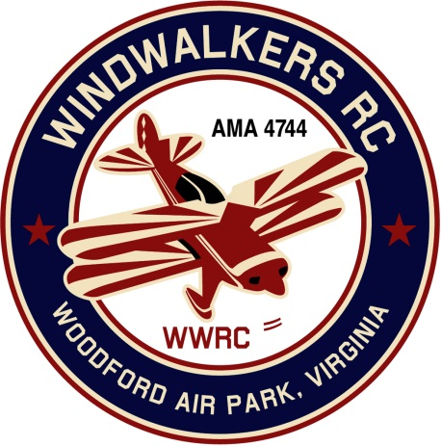
January 21, 2017
Monthly Club Meeting Minutes,
Club President, Gary Stone, called the meeting to order at 11:10 a.m. January 21, 2017. The meeting was held at Salem Library, Fredericksburg, VA 22407. The meeting was opened with the pledge of allegiance. There were 7 members in attendance.

Secretary’s Report:

- The minutes of the December 17, 2016 meeting were read.

Treasurer’s Report:

- Ending Balance in checkbook: $1,467.76
- Nothing pending

Field Safety Report:

- There was no safety report.

Old Business:

- Carry over from last meeting: Greg needs to know who wants a new logo shirt so he can give the information to Jay. Once received he will pass along and Jay will place the order.

New Business

- President Gary Stone invited Leo to the meeting we plan to hold at Shannon Airport. He and Pat will try to attend.

- A date for Aviation Day was voted on. June 10, 2017. Gary agreed to run the date by Hank to ensure there are no other conflicts. It takes a month or so to get this information in the AMA magazine.

- The Float Fly was voted on as well, June 24, 2017 .

- A motion was made to have the club pay for the new secretary’s AMA dues. Motion was second.

There being no further business, the meeting was adjourned at 11:55.

Respectfully Submitted,

Cindy B.

