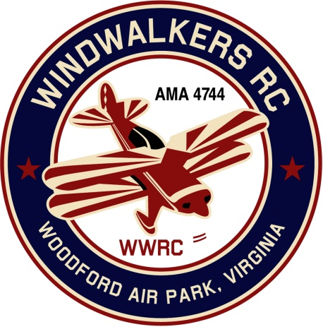
March 11, 2017
Monthly Club Meeting Minutes,
Club President, Gary Stone, called the meeting to order at 10:10 a.m. March 11, 2017. The meeting was held at Shannon Airport Fredericksburg, VA 22407. The meeting was opened with the pledge of allegiance. There were 10 members in attendance.

Secretary’s Report:

- Minutes from the Feb. meeting were read and approved.

Treasurer’s Report:

- Ending Balance in checkbook: $1,347.76
- $38.54 pay pal
- Total Assets: 1,386.30
- Nothing pending

Field Safety Report:

- There was no safety report due to cold weather and not much flying.

Old Business:

- Carry over from last meeting: Greg needs to know who wants a new logo shirt so he can give the information to Jay. Once received he will pass along and Jay will place the order. Update: Shirts were brought to last months meeting and those that wanted to purchase them filled out an order form. Red is only available in mesh. Color blue is a little different from what we saw. Confirmation of what everyone wanted was passed around. To save shipping he will hand deliver the shirts.
- Gary did send date to AMA a couple of weeks ago. We have not heard back from them as of today.

- April 22, 2017 confirmed for maintenance. Bring what you can to help. Eugene is bringing air compressor. Several runway lights on the field are broken. The club made the decision to try and fix them for Leo.

- Jim Braithwaite from The Aeromasters offered to do CD for aviation day. Don’t need extra insurance per Eugene. Hank will take care of porta john.

- Float Fly at Bealeton will be June 24, 2017

- Aviation Day June 10, 2017. Hank will get big prize and bring it. Bill Shultz ask if the SCC been taken care of, yes.

New Business

The Vice President Bill Shultze made a recommendation to change the by laws pertaining to medically discharged veterans. Motion was accepted to waive club dues for all veterans medically discharge with 100% disability. Motion was also made, seconded, and approved to waive the second reading of this motion at the next club meeting. The second vote to change the laws was read, seconded and approved.

- April 22nd at 10:00 am was suggested as a tentative day to do field maintenance. Eugene has all the supplies for the mower.

- Suggestion was made for everyone to visit some of the other events to promote our own aviation day. Eugene suggested making flyers up to promote our day at Joe Nall event. He and Greg will take them.

- Next meeting will be April 22nd at the field.

There being no further business, the meeting was adjourned at 10:29.

Respectfully Submitted,

Cindy B.

