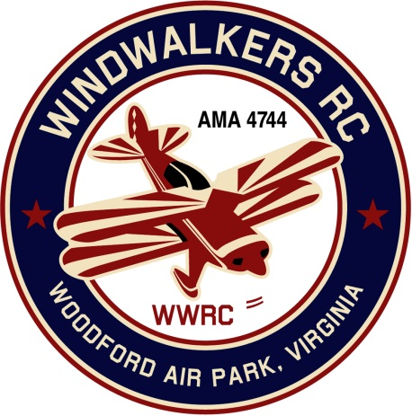
May 13, 2017
Monthly Club Meeting Minutes,
Club President, Gary Stone, called the meeting to order at 11:00 a.m. May 13 th, 2017. The meeting was held at Salem Library. The meeting was opened with the pledge of allegiance. There were 10 members in attendance.
***** Before the meeting began it was announced that our beloved friend and field owner Leo Caton had passed away. The club spent several moments telling stories about our fond memories with Leo******

Secretary’s Report:

- Club secretary was not in attendance do to family illness.
- Since there was no meeting in April due to all the bad weather, reading of the minutes was waved.

Treasurer’s Report:

- Beginning Balance in checkbook: $1,347.76
- $38.54 pay pal Deposits
- Total Assets: 1,386.30
- Nothing pending

Field Safety Report:
- There was no safety report due to bad weather and not much flying.

Old Business:

- The club discussed plans for Aviation day on June 10 th
- AMA had mistakenly used the flyer from last year for their site.

- The following people offered donations for aviation day :
- Kirk will donate the 50cc gas engine he won last year for the grand prize ( Thank you Kirk.)
- Hank will be handling prizes
- The club will pay for burgers and dogs
- Kirk and Jaimie will bring buns
- Bill will bring his bean salad
- Greg will see that the flying field is mowed
- Gary and Cindy will bring chips, plates, and condiments

- Float Fly at Bealeton will be June 24, 2017

New Business

A motion was made , seconded, and passed unanimously that we rename our National aviation day from this point forward to the “Leo Caton Memorial Model Aviation day” in honor of Leo.
The club also discussed anything that we could do to help the family going forward

There being no further business, the meeting was adjourned at 10:29.

Respectfully Submitted,

Cindy B.

