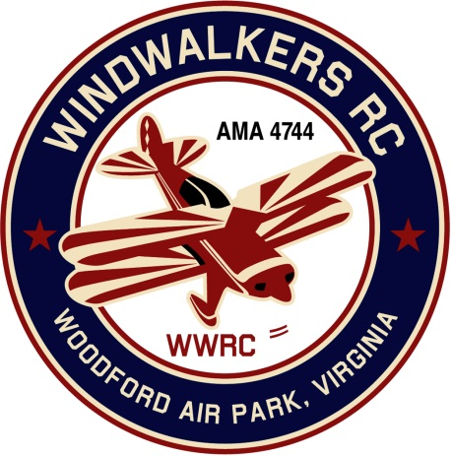
November 11, 2017
Monthly Club Meeting Minutes,
Club President, Gary Stone, called the meeting to order at 10:08 a.m. November 11, 2017. The meeting was held at Salem Library. The meeting was opened with the pledge of allegiance. There were 8 members in attendance.

Secretary’s Report:

- The meeting minutes from October 7th were read and accepted.

Treasurer’s Report:

- Beginning Check Book Balance: $2,416.30
- Paid Website charge $16.99
- Ending Check Book Balance: $2,399.31
- Nothing pending

Field Safety Report:

- There was no safety report.

Old Business:
- The 2017 Harvest Festival at Shannon Airport., was discussed. Hank was very pleased with our new location and set up. Shannons nexts events with be in June and October of 2018.

New Business:

- The SCC renewal was 26.00$. Eugene has already paid it so we will deduct it from his dues.
- Gary received a phone call from the AMA. He gave the specifics on our donation to the Moss Clinic. They were very pleased.

- The Flying site assistant coordinator was approached at a recent event in regards to installing a flying site for Wilderness Resort. Gary agreed to walk the property to discuss install location or a static display. There are concerns due to the many restrictions in bordering state/park land.

Upcoming Events:
- The Windwalkers annual Christmas dinner will be at 2:00pm on Saturday December 2, 2017 at the Four Seasons Restaurant. Club officers will also be elected for 2018

Reminders:
- Annual dues are due in December.

There being no further business, the meeting was adjourned at 10:52.

Respectfully Submitted,

Cindy Burleson

