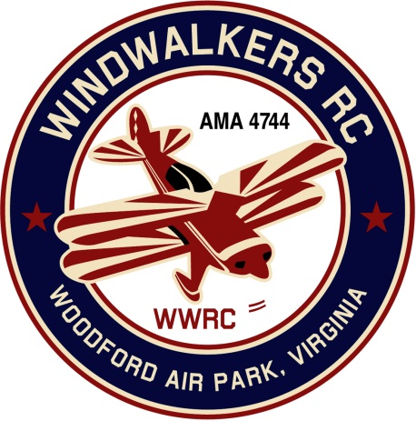
October 7, 2017
Monthly Club Meeting Minutes,
Club President, Gary Stone, called the meeting to order at 11:15 a.m. October 7, 2017. The meeting was held at Windwalkers flying field. The meeting was opened with the pledge of allegiance. There were 7 members in attendance.

Secretary’s Report:

- The meeting minutes from September 9th were read and accepted.

Treasurer’s Report:

- Beginning Check Book Balance: $2,416.30
- Ending Check Book Balance: $2,416.30
- Nothing pending

Field Safety Report:

- There was no safety report.

Old Business:
- We will be participating in the 2017 Harvest Festival at Shannon Airport., October 28, 2017, static display only. Shannon airport will not be a candy drop. Each club is encouraged to bring candy to give to the kids. We will be located in the same area we were last year.

New Business:

- Eugene fixed the shed door so it will lock, replenished gas and stabilizer for lawn equipment.

Upcoming Events:
- 2017 Harvest Festival at Shannon Airport., October 28, 2017

Reminders:
- December dues will be coming up soon.

There being no further business, the meeting was adjourned at 11:31.

Respectfully Submitted,

Cindy Burleson

