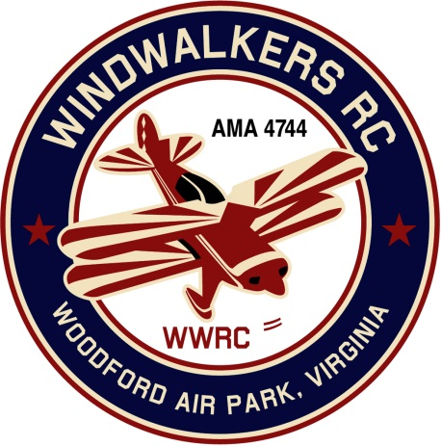
February 10, 2018
Monthly Club Meeting Minutes,
Club President, Gary Stone, called the meeting to order at 11:23 a.m. February 10, 2018. The meeting was held at Salem Library in Fredericksburg, VA. The meeting was opened with the pledge of allegiance. There were 6 members in attendance.

Secretary’s Report:

- The meeting minutes from January 13, 2018 were read and accepted.

Treasurer’s Report:

- Deposits for the month of January are $ 75.00 for dues
- Debit for the month: None
- Total balance on hand : $ 3,005.08

Field Safety Report:

- Due to bad weather and Minimal flying no safety issues were reported

Old Business:
- There was no old business to discuss

New Business:
- Mike brought in Patches for any club member who wished to purchase one, Eugene made a motion that the club purchase on for Johnny . Mike said he would donate a patch for Johnny. Motion was then amended to buy patches for Bobby and Johnny’s wife Alicia. Motion was seconded and passed .
- Dan asked how the club stacks up with requirements for spectator areas and such. Gary agreed to review the new AMA site rules and report back at the next meeting.
- Gary reported that the club charter packet was all filled out and awaiting to be mailed.

Upcoming Events:
- June 16, 2018, WindWalkers Model Aviation Day
- June 23, 2018, Float Fly, Lake Ritchie
- September 22, 2018 Float Fly, Lake Ritchie
- September 8-9, 2018 Fly-in Bealeton
- September 15, 2018 WindWalkers Boy Scout Day

Reminders:
- Annual dues are $75.00.

Miscellaneous:
- Mike still has more WindWalkers RC Club patches if you would like one or more. The cost is $26.00 per patch.

There being no further business, the meeting was adjourned at 12:03 pm.

Respectfully Submitted,

Gary Stone for Cindy Burleson

