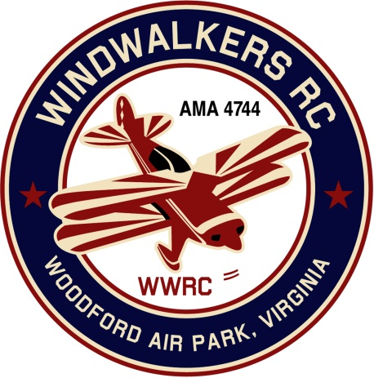
July 14, 2018

Monthly Club Meeting Minutes,
Club President, Gary Stone, called the meeting to order at 10:32 a.m. on July 14, 2018. The meeting was held at the Woodford Air Park in Woodford, VA. The meeting was opened with the pledge of allegiance. There were 7 members in attendance.

Secretary’s Report:

- The meeting minutes from June 9, 2018 were read and accepted.

Treasurer’s Report:
- Deposited on 6-18-18 from Model Aviation Day $884.00
- Checks & Debits:
  - 6-15-18 $60.00 cash for receipts box
  - 6-23-18 $14.99 Web Site (last payment)
  - 6-23-18 $171.63 Porta Jon
  - 6-23-18 $90.51 Flowers

- Balance on hand : $3,454.95

Field Safety Report:

- New AMA flying site rules have been posted at the field.

Old Business:

- Scout Day sleepover needs to be confirmed with Johnny.
- Aviation Day video is now on u-tube.

New Business:
- Robert Golightly has re-joined WindWalkers. Welcome Robert!

Upcoming Events:

- September 8-9, 2018 Fly-in Bealeton
- September 15, 2018 WindWalkers Boy Scout Day
- September 22, 2018 Float Fly, Lake Ritchie

Miscellaneous:

There being no further business, the meeting was adjourned at 10:55 am.

Respectfully Submitted,

Cindy Burleson

