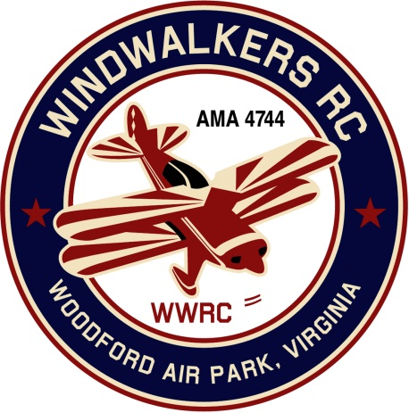
June 9, 2018

Monthly Club Meeting Minutes,
Club President, Gary Stone, called the meeting to order at 1:42 p.m. on June 9, 2018. The meeting was held at the Woodford Air Park in Woodford, VA. The meeting was opened with the pledge of allegiance. There were 6 members in attendance.

Secretary’s Report:

- The meeting minutes from May 12, 2018 were read and accepted.

Treasurer’s Report:

- Balance on hand : $2,908.08 (includes one persons membership dues in the amount of $75.00)

Field Safety Report:

- No safety issues reported.

Old Business:

- There was no old business to discuss.

New Business:
- On this day we also cleaned up the field in preparation for Aviation Day. (Grass cut, shed repair, fence set back up in front of porta jon and painted). Dan had already done the power washing.

Upcoming Events:

- June 16, 2018, WindWalkers Model Aviation Day
- June 23, 2018, Float Fly, Lake Ritchie
- September 22, 2018 Float Fly, Lake Ritchie
- September 8-9, 2018 Fly-in Bealeton
- September 15, 2018 WindWalkers Boy Scout Day(Affirmed)

Miscellaneous:

There being no further business, the meeting was adjourned at 2:00 pm.

Respectfully Submitted,

Cindy Burleson

