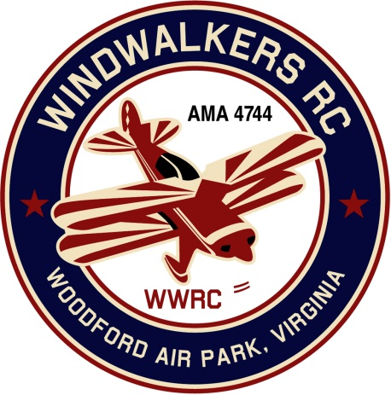
March 10, 2018
Monthly Club Meeting Minutes,
Club President, Gary Stone, called the meeting to order at 11:10 a.m. March 10, 2018. The meeting was held at Salem Library in Fredericksburg, VA. The meeting was opened with the pledge of allegiance. There were 7 members in attendance.

Secretary’s Report:

- The meeting minutes from February 10, 2018 were read and accepted.

Treasurer’s Report:

- Debit for the month:
  - AMA Renewal $120.00 paid 2-16-18
  - Mike(Club Patches) $52.00 paid 2-16-18
- Total balance on hand : $2,833.08

Field Safety Report:

- Due to bad weather and Minimal flying no safety issues were reported

Old Business:
- There was no old business to discuss

New Business:
- Dan asked how the club stacks up with requirements for spectator areas and such. Gary agreed to review the new AMA site rules and report back at the next meeting. Gary is currently reviewing the AMA rules and will report in our next meeting.
- Gary reported that the club charter packet had been filled out and will be mailed the week of the11th.

Upcoming Events:
- June 16, 2018, WindWalkers Model Aviation Day
- June 23, 2018, Float Fly, Lake Ritchie
- September 22, 2018 Float Fly, Lake Ritchie
- September 8-9, 2018 Fly-in Bealeton
- September 15, 2018 WindWalkers Boy Scout Day(Affirmed)

Miscellaneous:
- Mike still has more WindWalkers RC Club patches if you would like one or more. The cost is $26.00 for the large and $7.00 for the smaller patch.

There being no further business, the meeting was adjourned at 11:45 pm.

Respectfully Submitted,

Cindy Burleson

