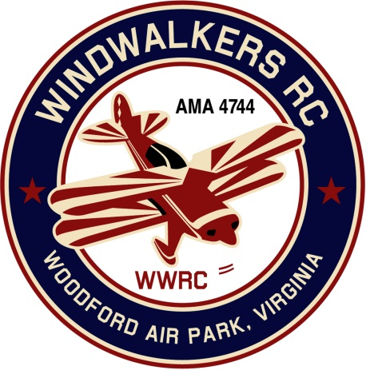
May 12, 2018

Monthly Club Meeting Minutes,
Club President, Gary Stone, called the meeting to order at 10:55 a.m. on May 12, 2018. The meeting was held at the Woodford Air Park in Woodford, VA. The meeting was opened with the pledge of allegiance. There were 6 members in attendance.

Secretary’s Report:

- The meeting minutes from March 31, 2018 were read and accepted.

Treasurer’s Report:

- Balance on hand : $2,833.08 (No change)

Field Safety Report:

- No safety issues reported.

Old Business:

- There was no old business to discuss.

New Business:
- Hank will schedule for the porta jon to be cleaned prior to Aviation Day June 16th.
- Gary verified that the 50cc engine we used as a door prize is in his possession. We will use it again this year as a door prize. He will check to see what else we have that could be included.
- During the next club meeting on June 9th we will conclude it by cleaning up the field. Gary will look for replacement shingles for the shed. (Grass cut, power washing, shed repair and set fence back up in front of porta jon.

Upcoming Events:

- June 9,2018 Womens Flyin @ Shannon Airport
- June 16, 2018, WindWalkers Model Aviation Day
- June 23, 2018, Float Fly, Lake Ritchie
- September 22, 2018 Float Fly, Lake Ritchie
- September 8-9, 2018 Fly-in Bealeton
- September 15, 2018 WindWalkers Boy Scout Day(Affirmed)

Miscellaneous:
- A suggestion was made to schedule a field workday. The shed roof needs to be repaired, fence around the porta-jon, and pressure wash the shelter.

There being no further business, the meeting was adjourned at 10:33 am.

Respectfully Submitted,

Cindy Burleson

