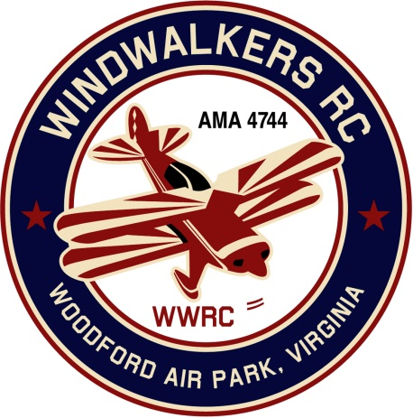
February 9, 2019
Monthly Club Meeting Minutes,
Club President, Gary Stone, called the meeting to order at 11:10 a.m. on February 9, 2019. The meeting was held at Salem Library, Fredericksburg, VA. The meeting was opened with the pledge of allegiance. There were 6 members in attendance.

Secretary’s Report:

- The meeting minutes from January 12, 2019 were read and accepted.

Treasurer’s Report:

- Balance per checkbook: $3,244.62

Field Safety Report:

- Nothing new to report

Old Business:
- Cindy will create the 2019 Aviation Day flyer and send it out to the 50+ RC clubs.
  - Gary will post the information on our Facebook page
  - Brian will update our Webpage
- Hank will verify that Eugene is still on the checking account. (Carry over from last meeting).
- Mike will get with the Scout Master to pick a date in September to do another Scout Day. (Carryover from last meeting)

New Business:
- Eugene will set up our June 8, 2019 Aviation Day in the AMA.
- Charter packet has arrived. Needs to be filled out and roster corrected then mailed in.
- Bill will be updating the Bi-laws 6.8

Upcoming Events:
- August 17, 2019 is AMA’s date for Model Aviation Day.
- May 18, 2019 Field Cleanup date (Lawn mower maint and install new porta Jon.)
- June 8, 2019 is our Aviation Day.

Miscellaneous:
- Dan wanted to know if we would be interested in hosting a Swap meet this Spring. Update: Hank will reach out to Aeromasters to see if they would like to participate as well. Update: Hank meeting with Aeromasters later this day. Will get response next meeting. (Carryover from last meeting)
- Dan found good pricing to do mower maint. (Oil, Gas, Air filter + 2Qts oil) $45.00

There being no further business, the meeting was adjourned at 11:37 a.m.

Respectfully Submitted,

Cindy Stone

